

BIOGRAPHY

***UNITED STATES ARMY***

**COLONEL J. THANE STARTZELL**

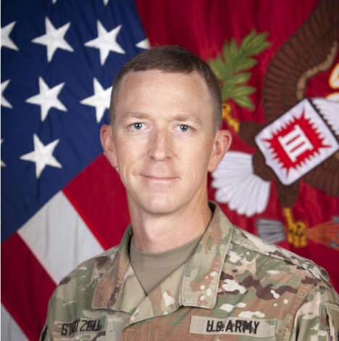COL Startzell is from San Antonio, Texas and a graduate of the US Military Academy at West Point with a Bachelor’s degree in Civil Engineering. He was commissioned as a U.S. Army Engineer in June of 2002.

COL Startzell's past assignments include the EUCOM Deputy Engineer; Command of the 3rd Brigade Engineer Battalion at Fort Cavazos, Texas from April 2020 to May 2022; 1st Cavalry Division Engineer; Deputy Commander of the US Army Corps of Engineers, Omaha District; Operations Officer for the 2nd Brigade Engineer Battalion located at Fort Bliss, Texas; Brigade Engineer and Planner for 4th Brigade Combat Team, 1st Armored Division; J4 Engineer for CENTCOM-Forward Jordan; Tactical Command Post Engineer for 1st Armored Division Headquarters at Fort Bliss, Texas; Project Manager for the Norfolk District, US Army Corps of Engineers; Company Commander for Charlie Company, 9th Engineer Battalion at Schweinfurt, Germany during OIF 07-09; S4 and Assistant S3 for the 62nd Engineer Battalion at Fort Cavazos, Texas during OIF 05-07; Executive Officer in the 74th Multi-Role Bridge Company, and Platoon Leader in the 68th Combat Support Equipment Company at Fort Cavazos, Texas during OIF I.

COL Startzell's military education includes graduation from the Canadian Forces College National Security Programme, Command and General Staff College, Engineer Officer Basic and Captain Courses, Sapper Leader Course, and Air Assault School. Startzell is a licensed Professional Engineer in the Commonwealth of Virginia and a member of the Society of American Military Engineers, American Society of Civil Engineers, the Army Engineer Association, and the Association of the United States Army.

COL Startzell's awards include the Bronze Star Medal, the Defense Meritorious Service Medal, the Meritorious Service Medal (2 oak leaf clusters), the Army Commendation Medal (1 oak leaf clusters), the Army Achievement Medal, the Iraq Campaign Medal (3 stars), and the Global War on Terror Expeditionary Service Medal.

COL Startzell and his wife Anna have four daughters: Virginia (13), Ivy (11), Annika (9), and Imogen (6).

July 2022